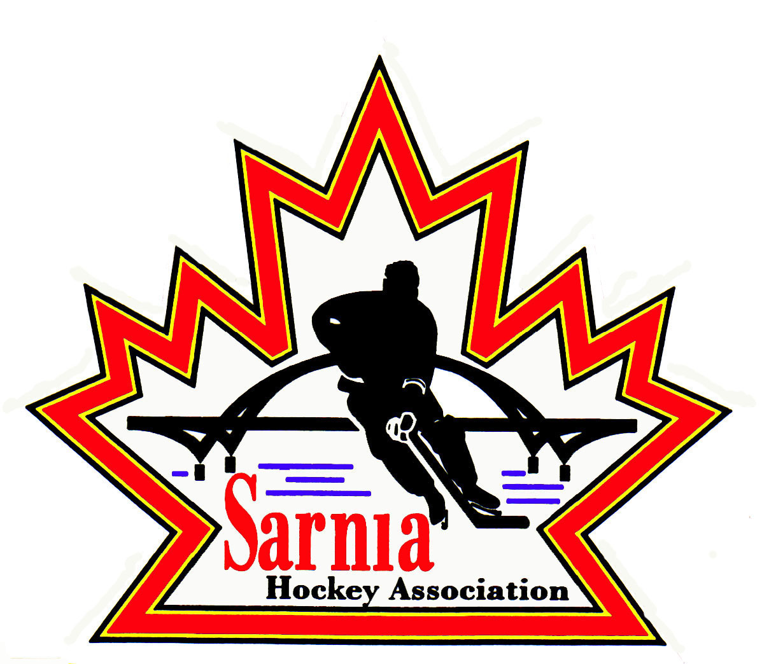

Sarnia Hockey Association

Minutes | Date: JULY 2, 2024 | time 7:00 pm

Meeting called by | Paul Walsh, President
Type of meeting | Regular
Secretary | Kelly Lane, Recording Secretary

Welcome | Paul Walsh, President, and meeting Chair welcomed everyone and called the meeting to order at 7:02 pm.

ATTENDANCE | Jerry Bernardo, Alister Brown, Emily Brown, Darren Chevalier, Ian Dunn, Pat Forbes, Dan Hunt, Kelly Lane, Linda Lauzon, Don McGugan, Kyle Mellor, John Mellor, David Penner, John Ritchie, Wayne Scarrow, Lesley Taylor-Smith, Kevin Taylor, Tim Turner, Barb Walsh, Paul Walsh  Regrets: Andrew Beasley, Jacquie Beasley, Chuck Ewart, Jeff Fogal, Terry Gray, Bonny Marcy, Jeff Needham, Ted Pendle, Jason Teather  Guest: Mike Hobin, Mike Derry

ACCEPTANCE OF MINUTES | MOTION #240702-001  “That the Minutes from June 19, 2024, be accepted as presented.” (Ritchie/Dunn)  Carried with one amendment  Expense increase for Bingo volunteers to be added to the motion.

TREASURER’S REPORT | - Player registration revenue is coming in. A lot of people paying in installments.  - Rep team loans – some are set up with bank accounts and are requesting their loans.  - Ice bill of $18,000 for U8 Jamboree came in after our year end books closed. There will be a reverse recognition for that.  MOTION #240702-002  “That the Treasurer’s Report be accepted as presented.” (E. Brown/Forbes)  Carried  REP TEAM BANK ACCOUNTS:  - 4 teams are 100% ready and 9 are in process. As of this morning, several managers are waiting for the Royal Bank Rep to respond. One team has been formed that haven’t submitted their paperwork to the bank, so they haven’t started their bank account process yet. A reminder was sent to the coach a few weeks ago and waiting for a response.  - U8 MD, 2 U9 teams and 2 U18 teams are in limbo until we go to fall tryouts. We need two signing authorities so we can’t move forward for these teams until their teams are formed. For the teams that don’t have bank accounts set up yet, we have ways for these teams to receive money for tournaments.

BILLS TO BE PAID | MOTION #240702-003  “That the bills be paid as presented.” (E. Brown/Dunn)  Carried
  Recipient | Expense | Amount
  BRA  City of Sarnia  Sportzhead  Jerry Bernardo  Alister Brown | Tryouts  Room Rental  Annual License  AGM mileage and expenses  AGM expenses and goalie equipment | $ 125.00  $ 201,72  $ 2,619.34  $ 308.75  $ 539.38

REGISTRAR | REGISTRATION REPORT:  - We still have 54 Rep players and 75 staff that still need to register. We also have transfers from Point Edward.  - Question about whether it would be worthwhile adding two additional teams to U6/U7. Last year we didn’t turn any player away. Not sure we will fill 2 additional teams, but we will monitor the situation.  - We already had ice slotted for 6 teams but 7 am ice is available Saturday and Sunday.  - We will order an additional two sets of Tim Hortons jerseys. Coordination of the colours to match below and upper divisions.  - We will do a Facebook boost for registration.
  DIVISION | REGISTRANTS
  Foundations | 79
  U6 /U7 | 72 FULL
  U8/U9 | 119
  U11 | 106
  U13 | 108
  U15 | 95
  U16 | 41
  U18 | 31
  U21 | 7
  TOTAL | 658

REP REPORTS | REP COUNCIL  - Finalized recommendations from the Structure Meeting. Season maps are out. They have been forwarded on to rep directors.  - Reviewed the schedulers’ schedule. Sarnia, Hamilton and Burlington are first off as we are the furthest away. Seeded scheduling will start the third week in July once AAA is done. Urgency to get tournaments and black out dates into Ice Scheduler.

REC VICE CHAIR | - Want to appoint a Director at Large for Special Events such as Sting Assist, Winter Classic, Skills Competition etc.  - Heather Amaral is the candidate.  MOTION #240702-004  “That Heather Amaral be appointed as Director at Large Special Events Co-ordinator for Rec.” (Bernardo/E. Brown)  Carried  - Haven’t heard back from Point Edward Minor Hockey but will connect to further discuss.

REC EQUIPMENT DIRECTOR | - Facilities group at the City are looking to update the Storage area at Clearwater Arena. Updated lighting, rubber mat flooring and they are working on consolidating space and improved storage for goalie equipment. It should be finished by mid to late July. There was a small pocket of money from the Cousi committee for goalie storage if we need it.  - They are going with cage storage for better ventilation. We will ask about lighting in the west storage area as well.  - We need security camera up and running for that area.  - We will ask the City to provide two keys.  - There has been no decision regarding the Sarnia Hockey office at this point.

ICE DIRECTOR | - 2024/25 season starts on September 3. We need to confirm the start date for Rec.  - Going with one permit for Rep and Rec.  - U10A, U12A, U16A, U10BB and U16BB have provided their tournament info.  - We have sent reminder emails but we may have to text these coaches to ensure they are receiving emails as they haven’t responded.  - Alliance reg season starts Sept 30.  - Seeded split Nov 24.  - BB will split Dec 15.  - BB teams will cross over again this year to the east teams.  - 2 teams requesting practice dates. Ice Scheduler will review but no guarantee.  - Posing question about scheduling Rec games through the week.  - U10A and U11A, U8/9 BB to U11BB will not have games scheduled over March Break. U12-18 will have games.  - Teams that are entering “events” need to send these to Ice Scheduler.  - U13A is doing a fundraiser taking two days on a weekend as they already have their tournaments.  - Applied for insurance for July 1 to Mar 31 but we don’t have certificates yet. Tracy from Alliance will look at it. One SHA team is renting ice in Mooretown. Alliance indicated they will cover it even though we don’t have the certificates. Alliance is extending it knowing it will come back dated as of July 1. However, these teams will have to rent the ice and pay the premium as they are not to be having team sanctioned ice in July and August.  - Two teams doing fundraisers Oct 26/27 and U13 are having a 90’s dance on Sept 27 and that venue has insurance.  - There will be a coaches meeting in July. It will be an online meeting as we get better attendance.  - U9 – recommended to have 2 tournaments before moving to full ice and two with full ice.  - St. Thomas has dropped out of the Alliance and gone back to OMHA.  - Need to know before scheduling whether teams want double headers.  - City has not confirmed black out dates yet.

CLINIC DIRECTOR | - D1 Clinic is open to the public now.  - Info is on the website.  - It will be posted on the OHF website as well.  - Everyone from Sarnia Hockey that has to have D1 has registered.

NEW BUSINESS | COUSI COMMITTEE:  - Mike Hobin and Mike Derry from the Cousi Committee attended the SHA meeting and provided the Board with information about the golf tournament and how they will work with Sarnia Hockey.  - They started the golf tournament in 2017. For the first number of years money was raised for Juvenile Diabetes, however they wanted to support a more local sporting group and most of the committee played hockey. Sue Allen came up with the idea of raising money for Sarnia Hockey. This put more energy into the tournament and they want to establish a good rapport with SHA and complement what SHA is already doing. The Cousi Committee have two focuses – to help underprivileged kids become involved and to develop goaltenders. Ryan Cousineau was a goaltender and whom the tournament is named for. Last year we were able to purchase goalie equipment and pay for some goalie clinics. This year’s tournament should raise approximately $25,000. They are willing to support both rep and rec goalies. They would like to see a liaison with SHA and Mike Hobin and Wayne Archer. They are requesting SHA set up a budget ie running clinics, equipment, player support and then do a second half budget with the remainder of the money.  - SHA explained First Shift and Take a Shot initiatives.  - Cousi Committee wants to focus on goalies. They want to interview 3 goaltending coaches locally to see what the needs are.  - They want some longevity in the program and want people from SHA to become involved on their committee as well to help to run the tournament. This year’s tournament is July 27. The tournament is sold out.  NEXT MEETING:  - Next meeting is Wednesday, July 17, 2024, at 7:00 pm at Clearwater Arena Lower Hall.

adjournment | MOTION #240702-005  “That the meeting be adjourned.” (Scarrow )  Carried

Paul Walsh Kelly Lane
President Secretary

